# A Report on

Time Frequency Analysis of FMCW Radar Data

# Submitted by

Ayush Mall 2016A3PS0163G

Kushagra Shah 2016A3PS0167G

# Under the guidance of

Dr. A. Amalin Prince

Associate Professor and Head, EEE Department

# In partial fulfilment of the

Laboratory Project (EEE F366)

# At

# BITS Pilani, K.K. Birla Goa Campus

(Second Semester, 2018 – 2019)



# ACKNOWLEDGEMENTS

We would like to use this opportunity to express our gratitude to everyone who supported us throughout the course of this project. We are thankful for their aspiring guidance, invaluably constructive criticism and friendly advice during the project work. We are sincerely grateful to them for sharing their truthful and illuminating views on the number of issues related to the project.

We would like to thank *Dr. A. Amalin Prince* for giving us this great opportunity of working under him on such an interesting topic. We would like to extend our gratitude do *Dr. Gibin Chacko George* for his constant support, words of wisdom and timely suggestions.

We would also like to thank everyone else who was directly or indirectly involved to provide us with this opportunity.

Ayush Mall

Kushagra Shah

# ABSTRACT

This report gives an outline of the aim of the project and its applications. The aim is to analyse the previously studied methods for FMCW Radar Signal Processing and implement an efficient algorithm on FPGA to derive an accurate spectrogram for reflectometry data. The different approaches used involve various signal processing concepts – baseline wandering removal, signal normalisation, signal conditioning (using bandpass filter/ wavelet decomposition / empirical mode decomposition). The spectrogram of the signal obtained after processing the signal is compared with that of the original signal.

The algorithms have already been simulated and tested on MATLAB using the available libraries. The design implemented in the form of a python coded GUI is used to verify the obtained output. The algorithms are slightly modified to make it implementable on FPGA. Vivado HLS is used as the environment to implement the algorithms on Zynq Zedboard.

# TABLE OF CONTENTS

Cover Page…………………………………………………………………………………………………….. 1

Acknowledgements……………………………………………………………………………………….. 2

Abstract…………………………………………………………………………………………………………. 3

List of Figures…………………………………………………………………………………………………. 5

Background.…………………………………………………………………………………………………… 6

Baseline Wandering Removal............................................................................. 7

Signal Normalisation………………………………………………………………………………………. 8

Signal Conditioning............................................................................................. 9

Band Pass Filter……………………………………………………………………………………. 9

Wavelet Decomposition……………………………………………………………………… 10

Empirical Mode Decomposition…………………………………………………………. 12

Alternate Approach……………………………………………………………………………………… 13

Spectrogram………………………………………………………………………………………………… 14

Modifications……………………………………………………………………………..………………… 15

References…………………………………………………………………………………………………... 16

Appendix…………………………………………………………………………………………………...… 17

# LIST OF FIGURES

Figure 1 – FMCW Radar up chirp……………………………………………………………………. 6

Figure 2 – Example of baseline wandering removal………………………………………… 7

Figure 3 – Original signal plots……………………………………………………………………….. 7

Figure 4 – Baseline wandering removed from the signal………………………………… 7

Figure 5 – Signal normalised by method 1……………………………………………………… 8

Figure 6 – Signal normalised by method 2……………………………………………………… 8

Figure 7 – Signal conditioning using Band Pass Filter……………………………………… 9

Figure 8 – Computing the DWT…………………………………………………………………….. 10

Figure 9 – Signal conditioning using Wavelet Decomposition……………………….. 10

Figure 10 – Computing the Dual Tree Complex WT………………………………………. 11

Figure 11 – One iteration of the Sifting process……………………………………………. 12

Figure 12 – Several IMFs of a signal……………………………………………………………… 12

Figure 13 – Instantaneous amplitude and phase of a signal…………………………. 13

Figure 14 – Signal normalisation using Homomorphic Filtering…………………….. 13

Figure 15 – Spectrogram of original data……………………………………………………… 14

Figure 16 – Spectrogram of processed data…………………………………………………. 14

Figure 17 – ‘Old Approach’ versus ‘New Approach’…………………..…………………. 15

Figure 18 – Flowchart to justify the modification…………………………………………. 15

Figure A1 – GUI following the standard approach………………………………………… 17

Figure A2 – GUI following the alternate approach………………………………………… 18

# BACKGROUND

Reflectometry is used to detect or characterise object using the reflection of waves at the surfaces and interfaces of the object. This technique is used to study the properties of plasma using FMCW (Frequency Modulated Continuous Wave) signals.

In this method, the emitted radar signal gets reflected by the plasma surface when the frequency of the signal matches the plasma surface’s frequency. The reflected signal is received after some time “t”. The FMCW-Radar transmits a high frequency signal whose frequency increases linearly during the measurement phase (up-chirp).

Figure 1 – FMCW Radar up-chirp

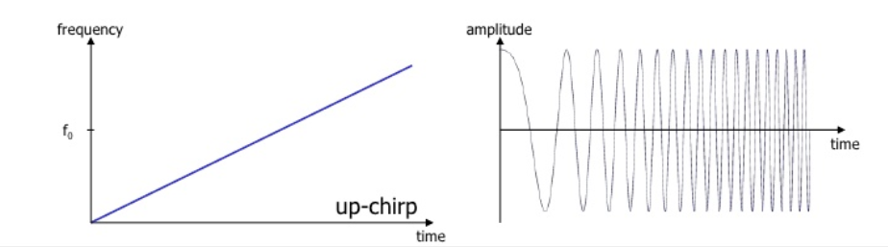

Due to the small magnitude of distance, it is difficult to accurately calculate the delay time. Hence, the frequency difference Δf is calculated from the actual transmit frequency and the receive frequency. This difference is directly proportional to the distance. It is transformed via a Fourier transformation (STFT) into a frequency spectrum and then the distance is calculated from the spectrum.

For this project, the sampled data of the received signal is already available. The aim of the project is to process the reflectometry data to obtain an accurate spectrogram. For achieving this, a number of methods are applied. The signal is first filtered to remove baseline wandering. It is then normalised (by using some threshold parameters), because an FM signal has a constant magnitude ideally. Finally, the signal is conditioned using one of the three techniques – bandpass filter, wavelet decomposition, empirical mode decomposition. Through this, we can obtain a better spectrogram because only the essential components of the signal are kept. For plotting the spectrogram, we are using the Short Term Fourier Transform (STFT).

Another approach is also tried where the signal normalisation is done using the concept of homomorphic filtering. For this, the process of signal conditioning has to be done before normalisation, and some thresholds have to be used for normalisation. The advantage of this method is its computational simplicity.

The simulations are done on both MATLAB and python coded GUI. The results are compared using correlation and are found to be almost same. Hence, in the following sections, only the python coded GUI’s simulation results are shown.

# BASELINE WANDERING REMOVAL

The baseline of the signal should deviate as little as possible from a horizontal line. But due to electric signal fluctuations, temperature fluctuations and other factors, there is a short time variation of the baseline from a straight line. This is called baseline wandering.

Figure 2 – Example of baseline wandering removal in ECG signals

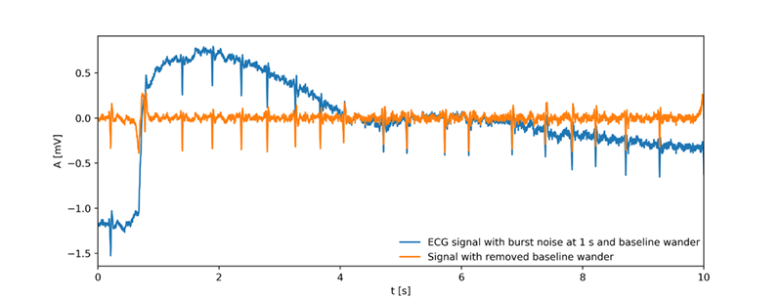

The baseline drift is usually of very low frequency. If the frequency is sufficiently low such that the signal frequency does not lie in that range, then a high pass filter can easily be used. Fortunately, this is our case, and we can simply use a high pass filter for baseline wandering removal. The same result can also be achieved by using a low pass filter and subtracting the filtered signal from the original signal. Both of these methods were used for analysis purposes.

Figure 3 – Original signal plots from the data file “**30418_CH0x-04.txt**”

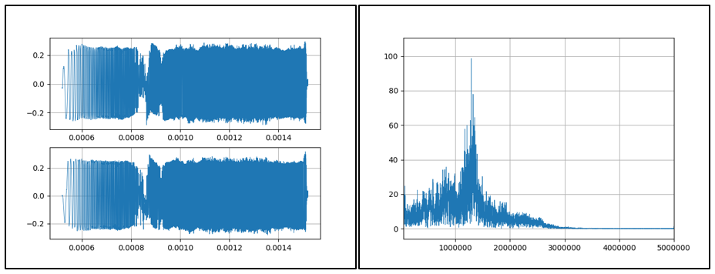

Figure 4 – Baseline wandering removed from the signal

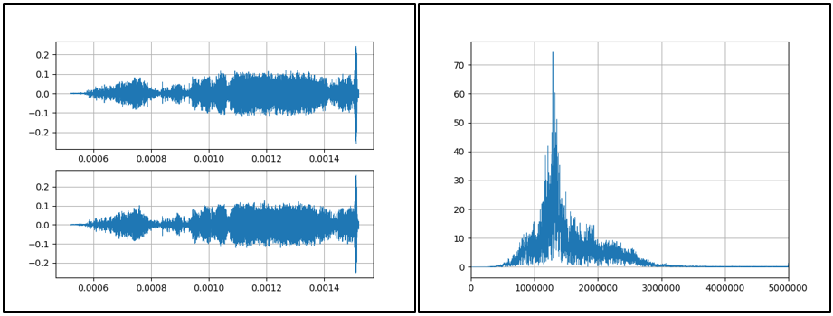

# SIGNAL NORMALISATION

To normalise a signal, a constant amount of gain is generally applied to bring the amplitude to a target level. But if the signal amplitude varies dynamically, application of constant gain does not serve the purpose. Hence, we use automatic gain control (AGC) where the peak output signal level is used to dynamically adjust the gain of the amplifiers. Effectively, AGC lowers the “too high” parts and raises the “too low” parts of the signal. AGC is used in our signal processing unit to overcome the unwanted clutter echoes. This method relies on the fact that clutter returns far outnumber echoes from targets of interest.

We have used two different techniques for signal normalisation:

1. The maximum and minimum envelopes of the signal are detected. For finding the envelope, the local maxima and minima are found. If any maximum/minimum lies below a certain threshold amplitude, then it is neglected. The envelope is then found out by using the Cubic Spline interpolation method. This envelope is used as the peak for deciding the variable gain, which is multiplied with each sample of the signal.
2. The modulus of the sampled signal is taken, and the peaks are found out. The envelope is then found out using the Cubic Spline interpolation method. This envelope is used to find the variable gain. If any value is smaller than a threshold, then it is amplified by the maximum gain to bring it closer to the threshold.

Figure 5 – Signal normalised by method 1

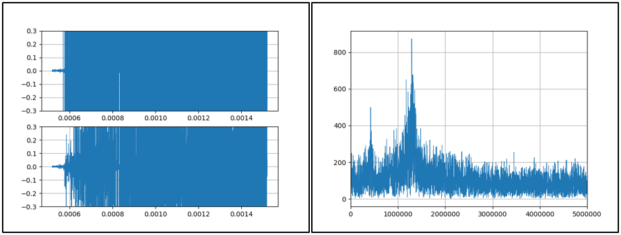

Figure 6 – Signal normalised by method 2

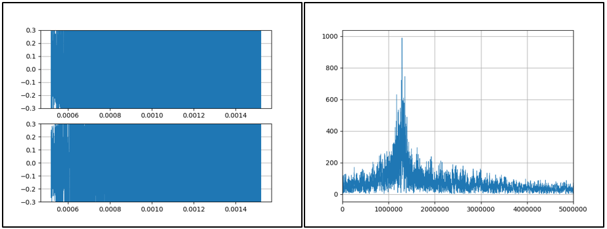

# SIGNAL CONDITIONING

Signal conditioning means manipulating the signal in such a way that it can be further processed. The signal can be amplified, filtered, isolated etc. because not all components of the signal contain valid data. Filtering is the most common method, where the unwanted components can be removed from the frequency domain. Filtering is essentially decomposition and reconstruction of the signal in the frequency domain. Certain methods allow us to do so in the time domain, which include Wavelet Decomposition and Empirical Mode Decomposition. Essentially, we have used three techniques:

1. A simple band pass filter is used to pass only the relevant frequencies of the signal.
2. Wavelet Decomposition is used to find out the wavelet coefficients for different levels. The signal is then reconstructed using only the significant wavelets. Unlike Fourier Transform, instead of decomposing the signal into time unlimited sine waves, it is decomposed into time shifted and scaled, time-limited wavelets.
3. Empirical Mode Decomposition is used to find out the Intrinsic Mode Functions (IMFs) of the signal. The signal is then reconstructed using only the significant IMFs. The first IMF usually carries the high-frequency components, hence, it can be rejected to remove random noise.

### BAND PASS FILTER

Often bandpass filtering is used to further attenuate the noise relative to the signal to improve the signal-to-noise ratio. We have used butterworth filter of variable order and pass band frequencies for analysis purposes.

Figure 7 – Signal conditioning using Band Pass Filter

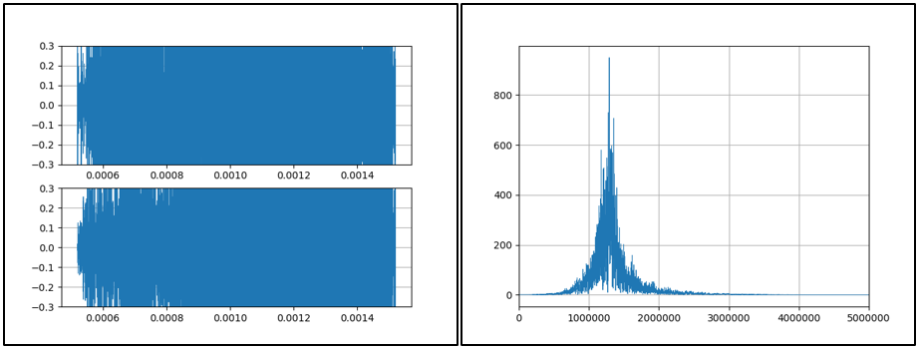

For some faults causing a very small reflection, the detection of the fault is very difficult because the amplitude of reflected wave is comparable to the level of noise. The traditional filtering methods may not be able to filter out the noise retaining the small reflected wave corresponding to the fault. Hence, other methods such as Wavelet Decomposition and Empirical Mode Decomposition can be beneficial.

### WAVELET DECOMPOSITION

The Fourier Transform gives the frequency information of the signal, which means that it tells us how much of each frequency exists in the signal, but it does not tell us when in time these frequency components exist. One way to overcome this short coming is Short Time Fourier Transform (STFT), in which the FT is taken after dividing the signal into small windows. By choosing the size of the window, one may get perfect time resolution or perfect frequency resolution, but not both. The Wavelet Transform (WT) solves the dilemma of resolution to a certain extent. WT implements something called a Multi Resolution Analysis (MRA), which analyses the signal at different frequencies with different resolutions. Every spectral component is not resolved equally as was the case in the STFT.

For computing the Discrete Wavelet Transform (DWT), filter banks are used for construction of the multi-resolution analysis. In DWT, low pass filters (LPF) and high pass filters (HPF) are used. The original signal is passed through the two filters and down-sampled, and the result is called the first level of wavelet transform. This is done iteratively to give detail and approximation coefficients.

Figure 8 – Computing the Discrete Wavelet Transform (DWT)

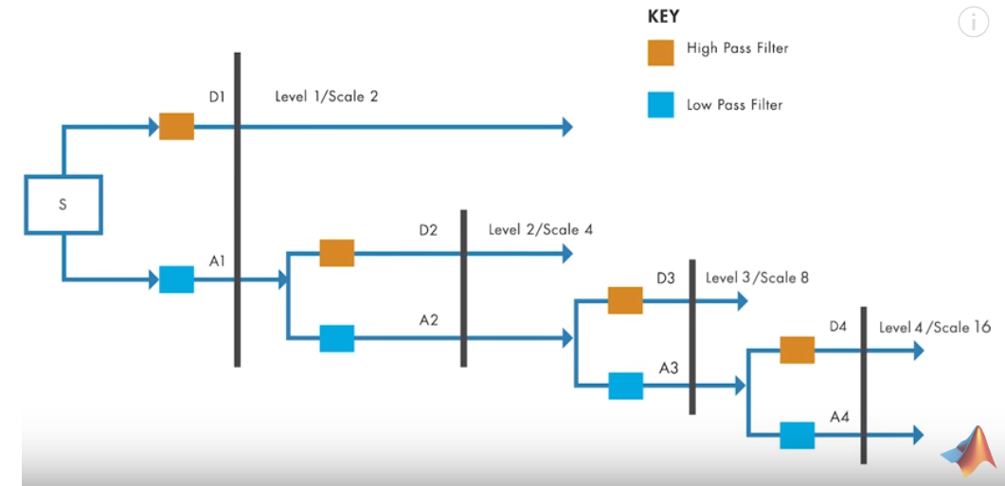

Wavelet de-noising technique has been applied in which wavelet transform is used to decompose a signal into N levels of lower resolution components using a mother wavelet. This decomposition results in N detail coefficients and one approximation coefficient. Only some of these coefficients are used and others are discarded for reconstructing the signal.

Figure 9 – Signal conditioning using Wavelet Decomposition

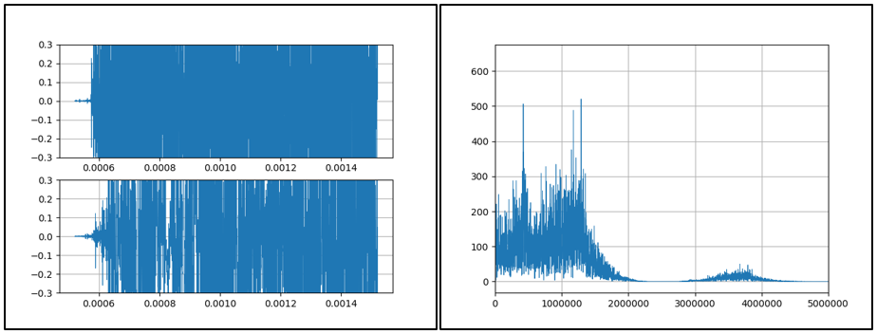

**NOTE on Complex Wavelet Transform (CWT):**

The simple wavelet transform can be implemented by set of filters that can divide signals for a particular time into sets of frequency bands. The coefficients of these filters can be derived from the mother wavelet for different translation and scaling factors, as discussed above.

The Dual-Tree Complex Wavelet Transform (DTCWT) calculates the complex transform of a signal using two separate DWT decompositions (tree “a” and tree “b”). If the filters used in one are specifically designed different from those in the other, then it is possible for one DWT to produce the real coefficients and the other to produce the imaginary coefficients.

The design of the filters is particularly important for the transform to occur correctly and the necessary characteristics are:

* The low-pass filters in the two trees must differ by half a sample period
* Reconstruction filters are the reverse of analysis
* All filters from the same orthonormal set
* Tree *a* filters are the reverse of Tree *b* filters
* Both trees have the same frequency response

This redundancy of two branches provides extra information for analysis but at the expense of extra computational power. It also provides approximate shift-invariance (unlike the DWT) yet still allows perfect reconstruction of the signal.

Figure 10 – Computing the Dual Tree Complex Wavelet Transform (DTCWT)

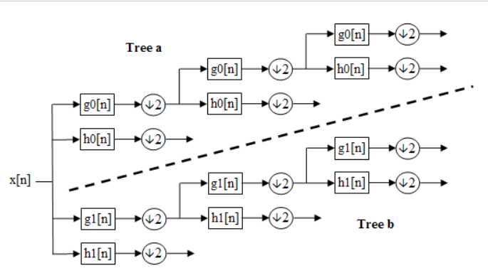

### EMPIRICAL MODE DECOMPOSITION

Empirical Mode Decomposition (EMD) is a method of breaking down a signal without leaving the time domain. The process is useful for analysing natural signals, which are most often non-linear and non-stationary.

EMD filters out functions which form a complete and nearly orthogonal basis for the original signal. The functions, known as Intrinsic Mode Functions (IMFs), are therefore sufficient to describe the signal, even though they are not necessarily orthogonal. The modes may provide insight into various signals contained within the data. The effective algorithm of EMD is the iteration of the following procedure:

Figure 11 – One iteration of the Sifting process

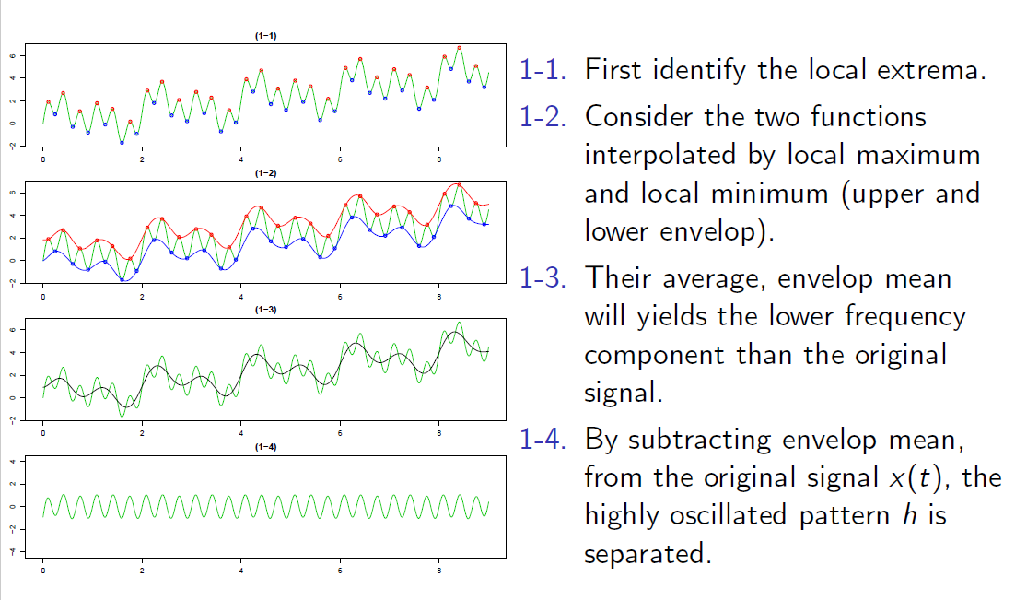

EMD is limited in distinguishing different components in narrow-band signals. The narrow band may contain either (a) components that have adjacent frequencies or (b) components that are not adjacent in frequency but for which one of the components has a much higher energy intensity than the other components.

Figure 12 – Several IMFs of a signal

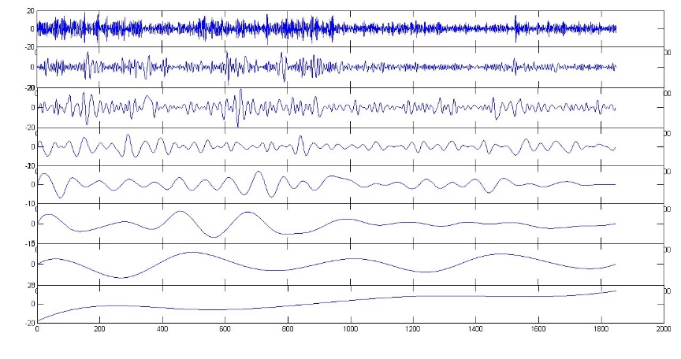

# ALTERNATE APPROACH

The approach followed till now involved the following sequence of operations: *Baseline Wandering Removal -> Signal Normalisation -> Signal Conditioning*. But if we use an alternate method for signal normalisation based on the concept of Homomorphic Filtering, then the sequence of operations should be as follows: *Baseline Wandering Removal -> Band Pass Filter (Conditioning) -> Homomorphic Filter (Normalisation).*

Figure 13 – Instantaneous amplitude and phase of a signal

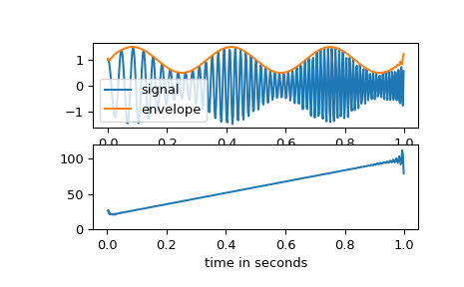

Homomorphic Filtering is a generalized technique involving a nonlinear mapping to a different domain in which linear filter techniques are applied, followed by mapping back to the original domain. In our case, we are calculating the instantaneous phase of the signal at each sampled point. The cosine of the instantaneous phase of the signal gives the real part of the normalised signal, and the sine gives the imaginary part. The envelope of the signal can be found out using the instantaneous amplitude.

Figure 14 – Signal normalisation using Homomorphic Filtering

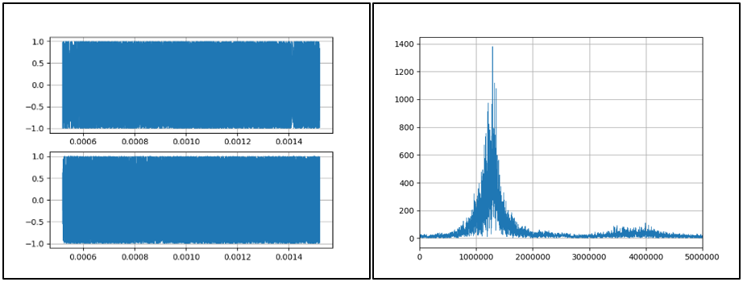

**NOTE:**

The above simulation shows the signal after baseline wandering removal, band pass filtering and normalisation using the homomorphic filtering concept.

# SPECTROGRAM

A spectrogram is a visual representation of the spectrum of frequencies of a signal as it varies with time. The spectrogram is basically the output of the STFT. The Short-Time Fourier Transform (STFT), is a Fourier-related transform used to determine the frequency spectrum in local sections of time called windows.

Fourier transform is performed on a short number of FFT points in a window. The larger the size of the window, the resolution in frequency domain increases but time domain becomes hazy. The windows can be of multiple shapes; the windows used by us are Hanning, Hamming, Blackman, and Bartlett.

Figure 15 – Spectrogram of original data for data file “**tIQdata_t57_1.txt**”

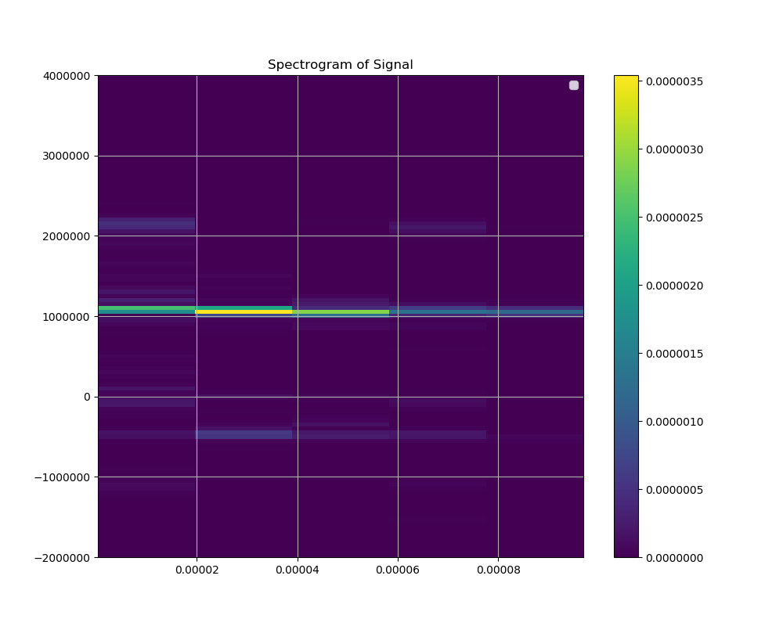

Figure 16 – Spectrogram of processed data for data file “**tIQdata_t57_1.txt**”

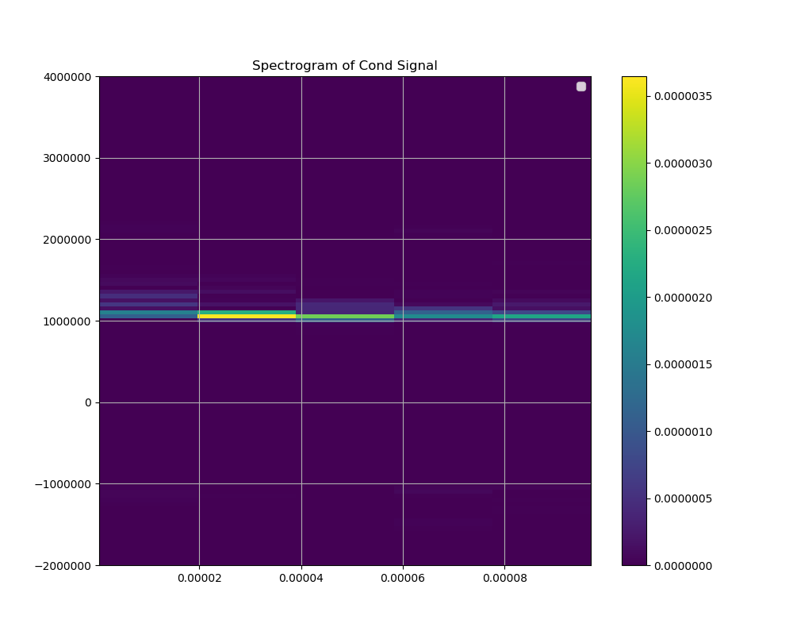

# Modification for Complex EMD

Some changes are necessary for implementing the complex EMD algorithm on FPGA. Modifications have to be incorporated according to the signal type:

1. **Real signal** – The original algorithm, real EMD can be used directly.
2. **Analytic signal** – The real and imaginary parts have to be treated separately. Hilbert Transform is used to combine the individual outputs.
3. **Complex signal** – The positive and negative frequency components are treated separately. Finally, individual outputs are combined using a different approach.

We need to implement the algorithm for the *analytic signal*. The approach that we were following till now is shown in Figure 17, where we are applying the real EMD algorithm on the real part of the input and its Hilbert Transform separately. This is compared to a standardised approach where real EMD is applied on the real part of the signal, and the Hilbert Transform of the output is taken.

Figure 17 – ‘Old Approach’ versus ‘New Approach’

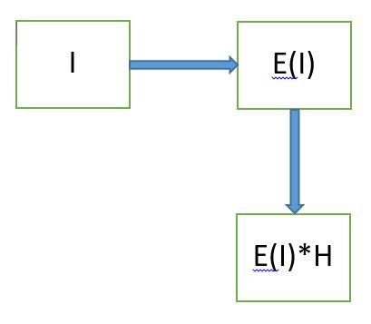 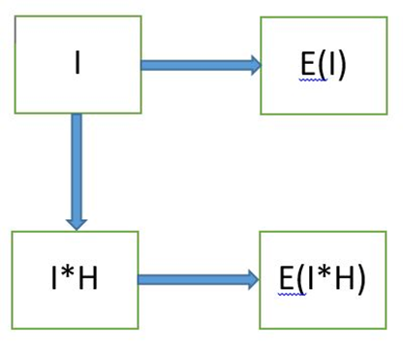

There is a flaw in the old approach: for both the above methods to be identical, E(I)*H has to be equal to E(I*H), which is not a general rule. The argument is further strengthened by the following flowchart.

Figure 18 – Flowchart to justify the modification

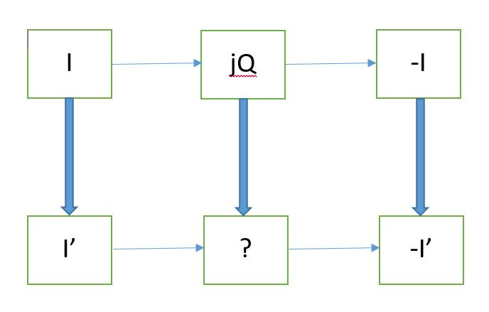

# REFERENCES

**Wavelet Decomposition:**

[The Wavelet Tutorial](http://web.iitd.ac.in/~sumeet/WaveletTutorial.pdf) by Robi Polikar

[The Dual-Tree Complex Wavelet Transform](http://people.math.sc.edu/blanco/IMI/DTCWT0.pdf) by Ivan W. Selesnick, Richard G. Baraniuk, and Nick G. Kingsbury

**Empirical Mode Decomposition:**

[Introduction to EMD with application to a scientific data](http://dasan.sejong.ac.kr/~dhkim/main/research/talks/EMDintroSeminar.pdf) by Donghoh Kim

**Homomorphic Filtering:**

[Envelope Extraction via Complex Homomorphic Filtering](http://citeseerx.ist.psu.edu/viewdoc/download?doi=10.1.1.48.1082&rep=rep1&type=pdf) by I.A.Rezek and S.J.Roberts

**Miscellaneous:**

MATLAB and Python documentations for syntax of the libraries used

Wikipedia for technical definitions

# APPENDIX

The data files used for simulation and analysis purposes are as follows:

* 30418_CH0x-02.txt to 30418_CH0x-07.txt
* linF-250us-5MSps-108p5cm.txt
* linF-250us-5MSps-132p5cm.txt
* linF-250us-5MSps-139cm.txt
* linF-250us-5MSps-150cm.txt
* linF-250us-5MSps-153p5cm.txt
* tIQdata_t57_1.txt
* tIQdata_t59_1.txt

The following are the screenshots of the python coded GUI:

Figure A1 – GUI following the standard approach

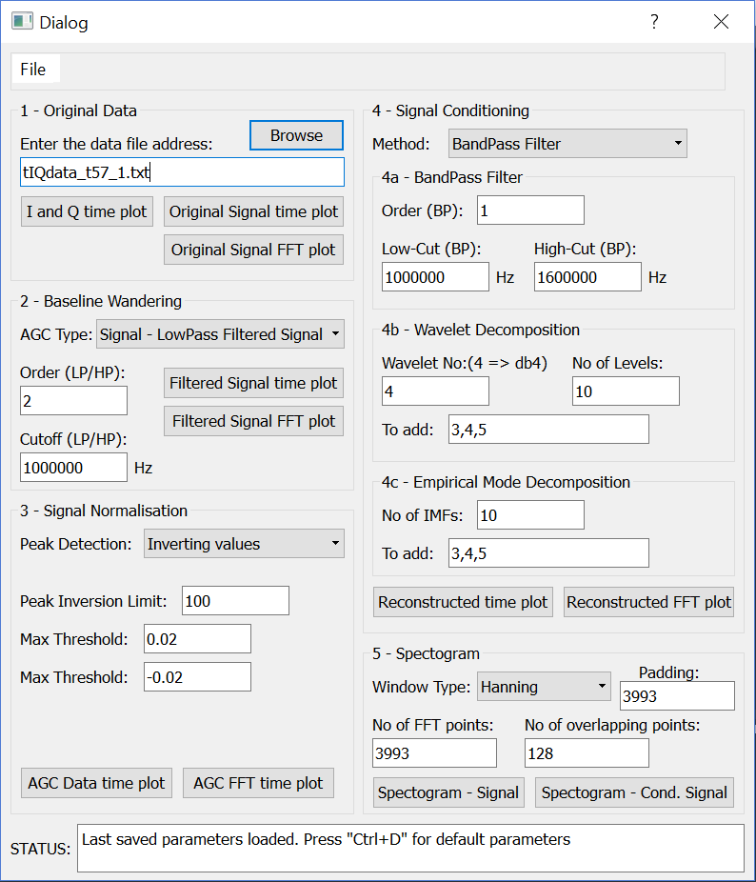

Figure A2 – GUI following the alternate approach

